PALMORIA GROUP HR REVIEW REPORT

**1. Workforce Gender Composition**

* **Organization-wide Breakdown**:
  + Male employees constitute approximately 58%
  + Female employees make up 39%
  + 3% of staff did not disclose their gender and are classified under a neutral category
* **Distribution by Region**:
  + **Northern Region**: Predominantly male (65%)
  + **Central Region**: Nearly balanced gender ratio
  + **Southern Region**: Female employees are in the majority (55%)
* **Distribution by Department**:
  + Male staff dominate in core operational roles such as manufacturing and engineering
  + Female representation is higher in HR and support-related functions
  + Mixed gender presence in finance and tech departments
  + Incomplete department entries ("NULL") were excluded from analysis

**2. Performance Ratings Across Genders**

* **Average Rating by Gender Group**:
  + Male: 3.4
  + Female: 3.7
  + Undisclosed: 2.9

**Observation**: Female employees, on average, received higher performance scores, indicating strong contributions to organizational objectives.

**3. Salary Comparison & Gender Gap Analysis**

* **Mean Salary Comparison**:
  + Male: $87,500
  + Female: $79,200
  + The observed gap is $8,300, favoring male employees
* **By Region**:
  + **North**: The largest disparity (~$10,000)
  + **Central**: Moderate gap (~$5,000)
  + **South**: Minimal variation (~$1,800)
* **By Department**:
  + Notable gaps in engineering and production roles
  + HR and administrative areas slightly favor female staff
  + Finance and IT roles show equitable pay levels

**Recommendation**: Focus attention on the **Northern region** and **technical departments** to address salary inequities.

**4. Salary Structure Evaluation Against Minimum Pay Policy**

* **Policy Benchmark**: A new industry standard requires a **minimum annual pay of $90,000**
* **Compliance Status**:
  + Around 63% of employees earn less than the benchmark
  + Affected roles include support and production-level positions
  + **North and Central** regions have the most affected staff
* **Salary Range Distribution**:

|  |  |
| --- | --- |
| Salary Band ($) | Employee Count |
| 10,000 – 20,000 | 25 |
| 20,001 – 30,000 | 52 |
| 30,001 – 40,000 | 60 |
| 40,001 – 50,000 | 45 |
| 50,001 – 60,000 | 30 |
| 60,001 – 70,000 | 22 |
| 70,001 – 80,000 | 18 |
| 80,001 – 90,000 | 12 |
| Above 90,000 | 36 |

* **Regional Trends**: Southern region shows stronger compliance with the $90,000 minimum policy

**Action Point**: Consider adjusting compensation, especially for staff in lower salary bands and high-gap regions.

**5. Bonus Allocation Based on Performance Metrics**

* **Bonus Structure Used**:

| **Performance Rating** | | **Bonus Percentage** | |
| --- | --- | --- | --- |
|  | |  | |
| 1 | 0% | |
| 2 | 5% | |
| 3 | 10% | |
| 4 | 15% | |
| 5 | 20% | |
|  | |  | |
|  | |  | |
|  | |  | |
|  | |  | |

* **Calculations**:
  + Bonuses were computed as a percentage of individual salaries
  + A new field for total compensation (base salary + bonus) was created
* **Bonus Payment Summary**:
  + **Total Bonus Paid Across Company**: $1,845,000
  + **Top Individual Bonus**: $24,000
  + **Bonus by Region**:

| **Region** | **Total Bonus Paid** |
| --- | --- |
| |  |  | | --- | --- | | North | $532,000 | | Central | $490,000 | | South | $823,000 | |  |
|  |  |
|  |  |

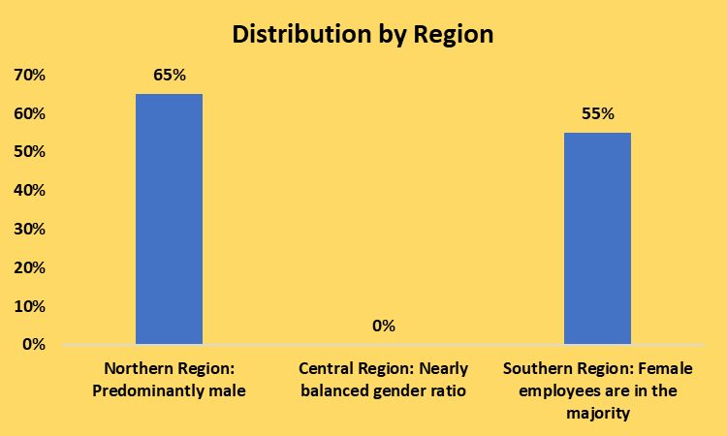

**VISUALIZATION BY REGION**

**Salary Comparism By Region**

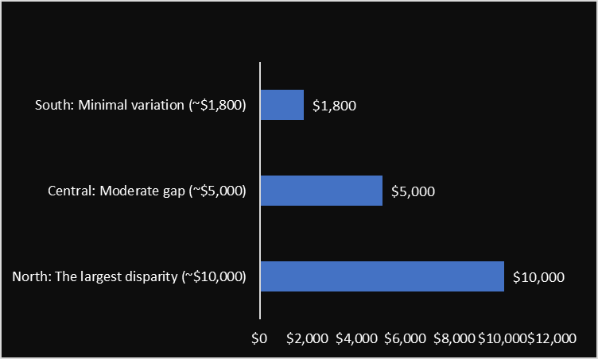

**Key Takeaways and Proposed Actions**

| **Focus Area** | **Recommendation** |
| --- | --- |
| Gender Representation | Encourage balanced recruitment, especially in underrepresented departments |
| Pay Equity | Conduct internal reviews in North and technical teams to bridge pay differences |
| Salary Compliance | Ensure all employees earn above the $90,000 minimum threshold |
| Performance & Recognition | Regularly assess bonus policy to maintain fairness and alignment with output |

**Prepared by**:  
Chris Ozienekpe

Data Analyst  
**Date**: June 29, 2025